BibTeX:  
@INPROCEEDINGS{6655798,   
author={I. F. M. S. d. Moura and L. S. Machado},   
booktitle={2013 XV Symposium on Virtual and Augmented Reality},   
title={Shader Integration in a Virtual Reality Framework},   
year={2013},   
pages={276-279},   
abstract={This paper discusses the integration of Shaders in a Virtual Reality framework named CyberMed, showing how this could enhance the system's realism by making it possible to include advanced Computer Graphics (CG) techniques. CyberMed's current and future structures are shown in this paper, emphasizing the new classes, which are responsible for Shader activities and generating some necessary CG functionalities.},   
keywords={computer based training;medical computing;realistic images;virtual reality;CyberMed;GLSL language;Shader activities;Shader integration;advanced computer graphics techniques;medical training;system realism enhancement;virtual reality;Augmented reality;Computer Graphics;CyberMed;Shaders;Virtual Reality;framework;structure},   
doi={10.1109/SVR.2013.38},   
month={May},}

**Bibliography**

Shaders are important component in the graphics programmable pipeline, executed in GPU, performing the parallel operations. Vertex Shader and Fragment Shader of the pipeline are responsible for implementing shading to each primitive/texture.

# The current paper titled “Shader Integration in a Virtual Reality Framework” focuses on integration of shaders in a Virtual Reality framework named CyberMed, thereby giving an overview of how this could intensify the system's realism by making it possible to include advanced Computer Graphics (CG) techniques.

# The article also focuses on the present and future aspects of CyberMed thereby emphasizing on the new classes responsible for Shader activities and generating mandatory graphic functionalities. The graphic part of CyberMed is completely implemented using the Compatibility Profile of OpenGL and GLUT. This means that the Fixed Pipeline is used, without any Shader participation. In the recent past, Virtual Reality (VR) has been used in many applications those include CAD systems, flight and driving simulators and systems applied to medicine.

# In the end, it is mentioned, the process of updating CyberMed to support Shaders is under progress, indicating there is large scope for the performance to improve. The next steps include changes in the loading structures model to make CyberMed able to work with more file formats, such as obj, and to store models in a way that facilitates the communication with Shaders. This stage is followed with, a reformulation of the View module, making it use the Core Profile of OpenGL.

# Finally, a class will be created to store and load automatically in the system some basic Shaders, without the necessity of additional specifications by users.

The figure below gives an idea of the entire architecture flow of this model:

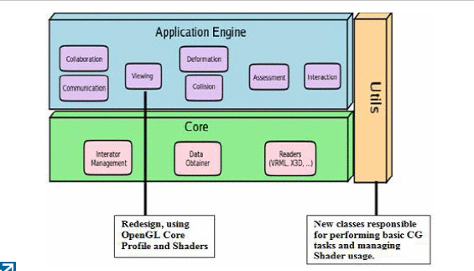

**References:**

* <http://ieeexplore.ieee.org.libproxy.uml.edu/search/searchresult.jsp?newsearch=true&queryText=shaders%20in%20computer%20graphics>
* <http://ieeexplore.ieee.org.libproxy.uml.edu/xpls/icp.jsp?arnumber=6655798>
* UML Library guides

"This is entirely my own work, except as disclosed in the documentation. I gave help to the following persons:   
None  
Signed Kiran C Shettar"